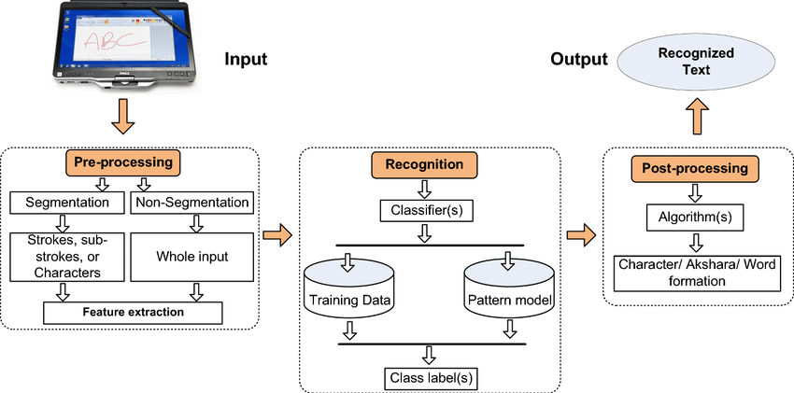

**Fig: Hand recognition system data flow diagram**